Operational Semantics of BFAE

Expressions

$e :≔n$ (num n)

$| e+e$ (add l r)

$| e-e$ (sub l r)

$| x$ (id s)

$| λx.e$ (fun x b)

$| e e$ (app f a)

$| ref e$ (newbox e)

$| e≔e$ (setbox b e)

$| !e$ (openbox e)

$| e ; e$ (seqn f s)

$| (e)$

Values and Environment

$a ∈Addr$

$σ ∈Env$*= $Var\underset{→}{fin} Val$*

$<λx.e, σ> ∈Closure$*= $Exp ×Env$*

$v∈Val$*= $Z+Closure+Addr$*

$M ∈Store$*= $Addr\underset{→}{fin} Val$*

Semantics



…









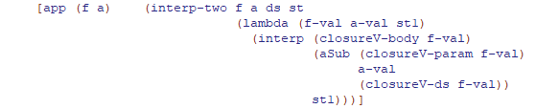

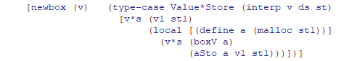

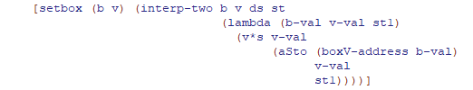

Even though the implementation in the textbook does not replace the value at the address $a$ into new given value, the intention of “setbox” is supposed to be replacement of the value at that address. Thus, it is reasonable to write down the operational semantics as shown in the above. (which specifies the condition of $a$ as a member of domain of $M_{2}$ and then change the value of )

